AE 4342-Lab7

1) “Aug 01 2026, 12:00:00” = 8.3886e+08

'Mar 01, 2027 12:0:0.0 = 8.5717e+08

2) Earth (from top to bottom): x-position, y-position, z-position, x-velocity, y-velocity, z-velocity

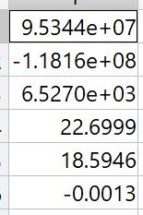

Mars (from top to bottom): x-position, y-position, z-position, x-velocity, y-velocity, z-velocity

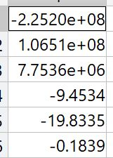

3) Porkchop plot of C3

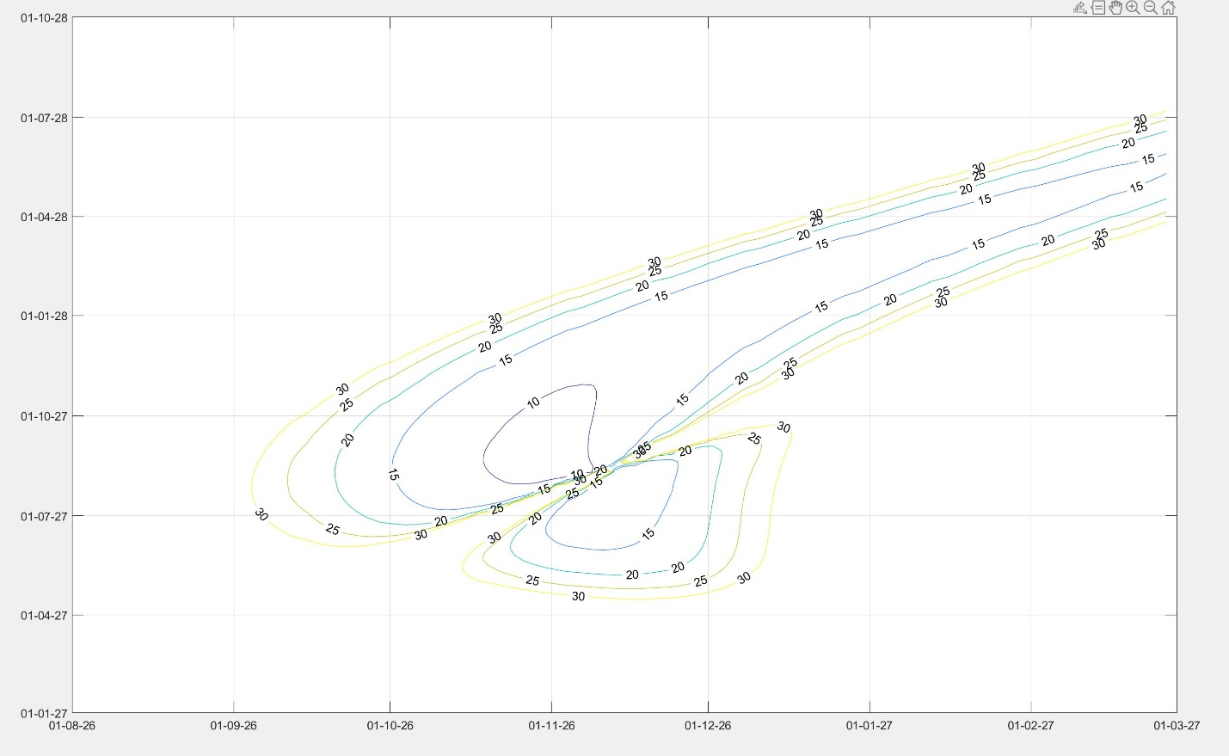

Porkchop plot of V-inf at arrival to mars

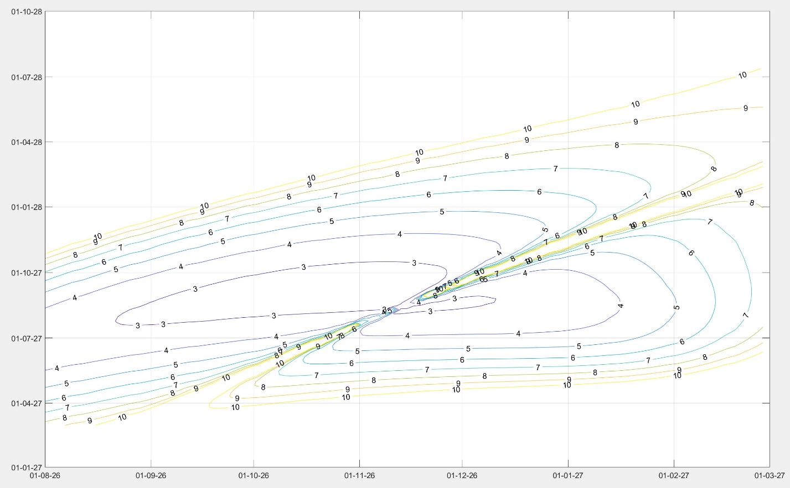

These were done by first computing the ephemeris time of earliest departure and arrival as well as latest departure and arrival. Then, using the linspace function, I chose 100 points between these two dates. Then, using a nested for loop (to go through each date combination), I calculated the velocities and positions of Earth and Mars using cspice_spkezr, calculated the time of flight by subtracting the specific arrival dates by the departure dates, used the provided glambert function to solve lambert’s problem, and finally found v_inf at departure and arrival by subtracting the planet’s velocity by the calculated craft velocity. These velocities were then normalized and v_inf departure was squared to get C3. I plotted v_inf arrival on a sperate diagram to make it clearer.

4) Then, I chose Oct 23, 2026 as the departure date with one of the lowest C3 needed, used ode 45 to solve the orbit from the initial conditions provided by glambert and Earth’s initial position. 6 differential equartions were used, 3 for dr = vel, 3 for vel = -mu*r/|r|^3. The orbits of planets were determined using cspice_spkezr over the course of 2 years (using a for loop)

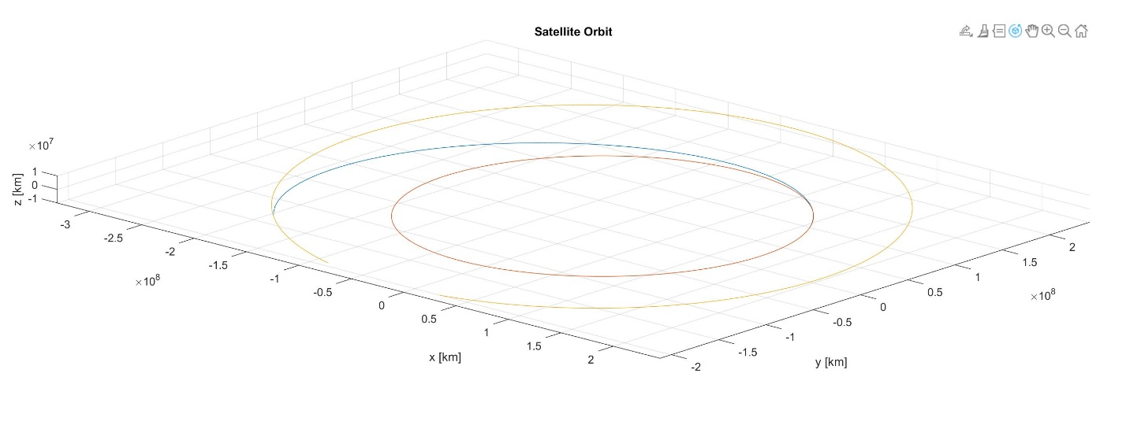

5) I got cassini’s position data between the dates provided using a similar method to q3, by converting the dates to ephemeral time and getting 1000 linearly spaced points. I then used cspice_spkezr for each of the dates, with Saturn as the observing body instead of the Sun. I was able to plot it easily, as shown by the figure below, 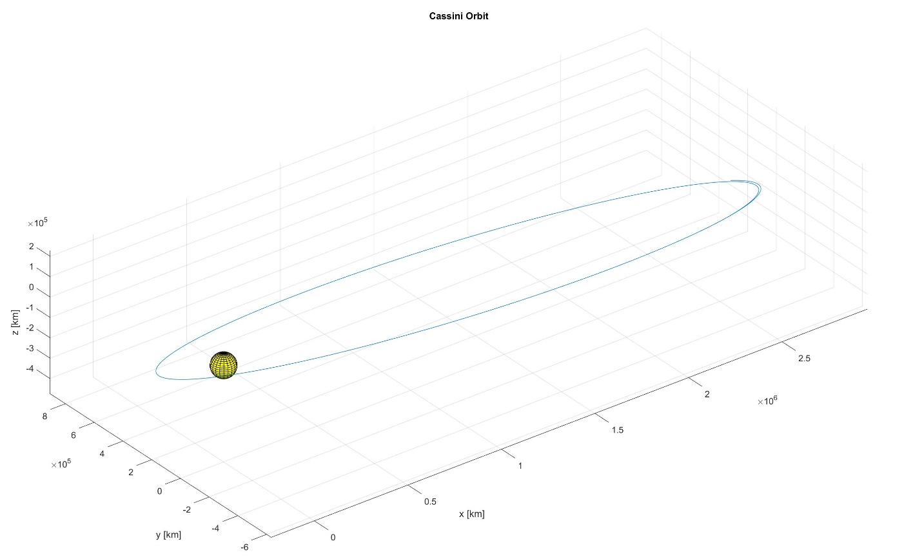

The Sphere was simply plotted by creating a sphere setting r=58232 (Saturn’s radius in km), and multiplying X, Y, Z by r to obtain a Sphere of Saturn’s size. Then the surf command was used to plot it.